# Using Line6 FBV with Kemper

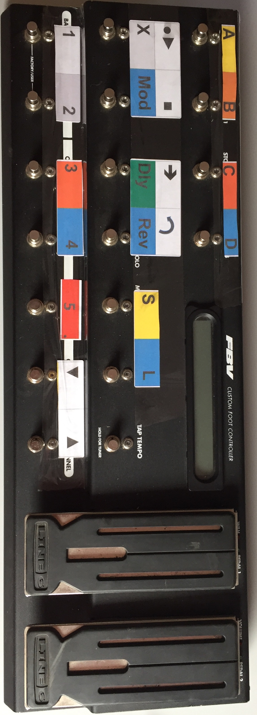

## Switches

|  |  |
| --- | --- |
| **FBV Switch** | **Usage** |
| FX Loop | FX Slot A |
| Stomp Box 1 | FX Slot B |
| Stomp Box 2 | FX Slot C |
| Stomp Box 3 | FX Slot D |
| Amp 1 | FX Slot X |
| Amp 2 | FX Slot Mod |
| Reverb | FX Slot Delay |
| Tremolo | FX Slot Reverb |
| Modulation | Solo Mode |
| Delay | Looper Mode |
| Tap Tempo | Tap Tempo/Beat Scanner(hold) |
| Bank Down | Performance Slot 1 |
| Bank Up | Performance Slot 2 |
| Channel A | Performance Slot 3 |
| Channel B | Performance Slot 4 |
| Channel C | Performance Slot 5 |
| Channel D | Bank Down |
| Favorite | Bank Up |

### Looper mode

Hold the Looper mode switch for 1 second to enter (or leave) the Looper mode.

Holding avoids accidentally switching.

In Looper Mode the swiches for the Post Effect section are used for the Looper Commands

|  |  |
| --- | --- |
| **FBV Switch (Looper Mode)** | **Usage** |
| Amp 1 | Rec/Play |
| Amp 2 | Stop/Erase(hold) |
| Reverb | Trigger |
| Tremolo | Undo |

### Solo Mode

Switching to solo mode will activate all available effects in the Post FX section.  
So with one switch you can add boost, delay, reverb….

Switching back will reset the effects like they were before.

## Pedals

|  |  |
| --- | --- |
| **FBV Pedal** | **Default Usage** |
| Pedal 1 | Wah |
| Pedal 2 | Volume |

### Assigning Pedal Functions

The last two characters in the Rig Name (length 32 characters) can be misused for the assignment.

Character 31 🡺Pedal 1

Character 32 🡺Pedal 2

Character values:

* V = Volume
* W =Wah
* P = Pitch
* M =Morph
* G = Gain

*If neither pedal is used for volume, the volume will be set to maximum.*

### Switches can be assigned different with little changes in the coding

Just replace these definitions

#define SWTCH_BANK_DOWN LINE6FBV_CHANNELD

#define SWTCH_BANK_UP LINE6FBV_FAVORITE

#define SWTCH_PRF_SLOT_1 LINE6FBV_DOWN

#define SWTCH_PRF_SLOT_2 LINE6FBV_UP

#define SWTCH_PRF_SLOT_3 LINE6FBV_CHANNELA

#define SWTCH_PRF_SLOT_4 LINE6FBV_CHANNELB

#define SWTCH_PRF_SLOT_5 LINE6FBV_CHANNELC

#define SWTCH_FX_SLOT_A LINE6FBV_FXLOOP

#define SWTCH_FX_SLOT_B LINE6FBV_STOMP1

#define SWTCH_FX_SLOT_C LINE6FBV_STOMP2

#define SWTCH_FX_SLOT_D LINE6FBV_STOMP3

#define SWTCH_FX_SLOT_X LINE6FBV_AMP1

#define SWTCH_FX_SLOT_MOD LINE6FBV_AMP2

#define SWTCH_FX_SLOT_DLY LINE6FBV_REVERB

#define SWTCH_FX_SLOT_REV LINE6FBV_PITCH

#define SWTCH_TAP LINE6FBV_TAP

#define SWTCH_SOLO LINE6FBV_MOD

#define SWTCH_LOOPER LINE6FBV_DELAY

#define SWTCH_LOOPER_START LINE6FBV_AMP1

#define SWTCH_LOOPER_STOP LINE6FBV_AMP2

#define SWTCH_LOOPER_TRIGGER LINE6FBV_REVERB

#define SWTCH_LOOPER_UNDO LINE6FBV_PITCH

## Hardware